**Title: Product and specification manual**

**1. Introduction**

This is a meter with RS232 and wireless GSM communication using Cicada GSM module. It has various event alerting functions including kWh remote reading and logging, using remote management and tampering provides customers a convenient remote reading method, on the air top-up. This meter is favored by customers and manufacturers with the features of high accuracy, wide measuring range and competitive cost performance.

**2. Tariff**

Tariff is software adjustable by energy provider as desired for meter.

**3. Communication**

Meter support RS232/2G/3G GSM, baud-rate: 115000.

**4. Measurement**

Meter measures voltage, current, active power and voltage is displayed on the 16x2 LCD, accumulative power and top-up history is logged every 24 hours on the web based software.

**5. Mode**

Meter has 2 operation modes:

1. On the air top-up.

2. STS token mode using keypad.

**Over the air top-up**

Over the air top-up is done via the web based software available, with meter to be topped up pre-registered with a unique meter-id, the rest is handled between the software and firmware to top-up the corresponding meter whose meter-id is entered automatically.

**STS operation**

Enter 20-digit token via keypad available on meter, the token is generated from the website in event of network failure or malfunction.

**6. Technical Parameter**

|  |  |
| --- | --- |
| **DESCRIPTION** | **SINGLE PHASE VALUE** |
| Accuracy | **CLASS 1** |
| **Voltage**  Reference voltage  Operating voltage range | 240 V  70% - 120% Reference voltage |
| Current | 5 (80A) |
| Frequency | 50Hz |
| **Temperature**  Operating range  Limit range for storage and transport | - 250C to 700 C  -400C to 1000C |
| **Power consumption**  Power consumption in voltage circuit(active)  Power consumption in voltage circuit(apparent)  Power consumption in current circuit | 2W  10VA  1VA |
| Communication Interface | DLMS / COSEM Compliance  (GPRS)First Electric web API |
| Dimension | 18cm x 15cm |
| Display: | LCD 16x2 |

**Indicator**

|  |  |  |
| --- | --- | --- |
| 1 | Credit Indicator | Bi-color LED (red)  Green LED light on when credit is in high level  Red LED light on when credit is low  Red LED blinks when credit has finished |
| 2 | Alarm indicator | The indicator blinks when event occur, event such as overload, low voltage, low credit or credit exhausted. |

**7. communication:**

1. RS232 communication, used for local reading/monitoring.

2. GPRS communication, used for on the air top-up, remote monitoring and controlling.

**8. Display of details on LCD**

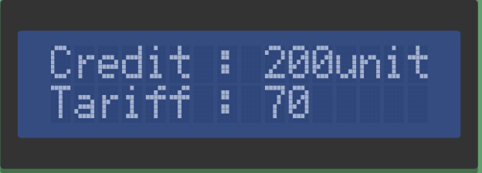



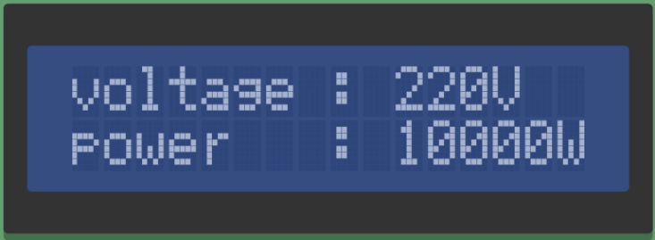

**9. Safety Instructions**

**Information for Your Own Safety**

This manual does not contain all of the safety measures for operation of this equipment (module, device) because special operating conditions, local code requirements or local regulations may necessitate further measures.

**10. Qualified personnel**

Installation and operation, assembling of this equipment described in this manual may only be performed by qualified personnel. Only people who have good knowledge on power/embedded system should assemble this equipment.